GARDEN GLORY PROJECT ASSIGNMENT
Please enter your answers directly into this assignment and instruction sheet for submission into D2L. Places for the answers have been highlighted in green.
At the end of the tasks, submit the following files into D2L for grading:
- This Microsoft Word assignment file with answers to the items
- Final DBC-e10-GG-Ch-7-Start.accdb database
- Final GG-DW Database-Ch-07.accdb database
- Final DBC-e10-GG-DW-BI-Exercises.xlsx spreadsheet file.
If you have not already implemented the Garden Glory database shown in Chapter 3 in a DBMS product, create and populate the GARDEN GLORY database now in the DBMS of your choice (or as assigned by your instructor). Not required, as the DBC-e10-GG-Ch-7-Start.accdb Access database has been provided for students in D2L.
- You should have about 14 existing PROPERY_SERVICE records in the database. Write the needed SQL statements for additional PROPERTY_SERVICE records.
Use the data below to develop the SQL code to insert additional records into the PROPERTY_SERVICE table. Provide the SQL code below. You do not need to enter the records into the PROPERTY_SERVICE table in Access. The file already contains the table and the additional records.

INSERT INTO PROPERTY_SERVICE (PropertyServiceID, PropertyID, ServiceID, ServiceDate, EmployeeID, HoursWorked) VALUES
(15, 1, 1, #2023-06-05#, 1, 4.5),
(16, 3, 3, #2023-06-08#, 1, 4.5),
(17, 3, 2, #2023-06-08#, 3, 2.75),
(18, 2, 2, #2023-06-10#, 5, 2.5),
(19, 6, 5, #2023-06-12#, 5,7.5),
(20, 5, 4, #2023-06-15#, 4, 2.75),
(21, 8, 4, #2023-06-19#, 2, 3),
(22, 4, 1, #2023-06-19#, 2, 2.5),
(23, 7, 4, #2023-07-05#, 3, 4.5),
(24, 1, 1, #2023-07-08#, 5, 4.5),
(25, 3, 3, #2023-07-08#, 4, 2.75),
(26, 2, 2, #2023-07-10#, 5, 2.5),
(27, 6, 5, #2023-07-12#, 3, 7.5),
(28, 5, 4, #2023-07-15#, 1, 2.75),
(29, 8, 4, #2023-07-19#, 2, 3),
(30, 4, 1, #2023-07-19#, 1, 2.5);
PropertyServiceID | PropertyID | ServiceID | ServiceDate | EmployeeID | HoursWorked
15 | 1 | 1 | 2023-06-05 | 1 | 4.5
16 | 3 | 3 | 2023-06-08 | 1 | 4.5
17 | 3 | 2 | 2023-06-08 | 3 | 2.75
18 | 2 | 2 | 2023-06-10 | 5 | 2.5
19 | 6 | 5 | 2023-06-12 | 5 | 7.5
20 | 5 | 4 | 2023-06-15 | 4 | 2.75
21 | 8 | 4 | 2023-06-19 | 2 | 3.
22 | 4 | 1 | 2023-06-19 | 2 | 2.5
23 | 7 | 4 | 2023-07-05 | 3 | 4.5
24 | 1 | 1 | 2023-07-08 | 5 | 4.5
25 | 3 | 3 | 2023-07-08 | 4 | 2.75
26 | 2 | 2 | 2023-07-10 | 5 | 2.5
27 | 6 | 5 | 2023-07-12 | 3 | 7.5
28 | 5 | 4 | 2023-07-15 | 1 | 2.75
29 | 8 | 4 | 2023-07-19 | 2 | 3
30 | 4 | 1 | 2023-07-19 | 1 | 2.5
- Design a data warehouse star schema for a dimensional database named GG-DW. The fact table measure will be HoursWorked. The GG-DW Database-Ch-07.accdb Access database file has been provided for you in D2L.
We’ll use a fact table named SERVICE_HOURS, a TIMELINE dimension table, a PROPERTY dimension table and an EMPLOYEE dimension table.
Provide both a star schema and the SQL code to create the following fact table and dimension tables. Create the schema in your drawing application of choice and paste a screenshot below. You do not need to create the tables in Access, but provide the SQL code below. Remember, the primary keys are underlined in the attributes listed below. Provide the star schema diagram and SQL code below:
SERVICE_HOURS(TimeID, PropertyID, EmployeeID, HoursWorked)
TIMELINE(TimeID, Date, MonthID, MonthText, QuarterID, QuarterText, Year)
PROPERTY(PropertyID, PropertyName, City, State, Zip)
EMPLOYEE(EmployeeID, LastName, FirstName, ExperienceLevel)

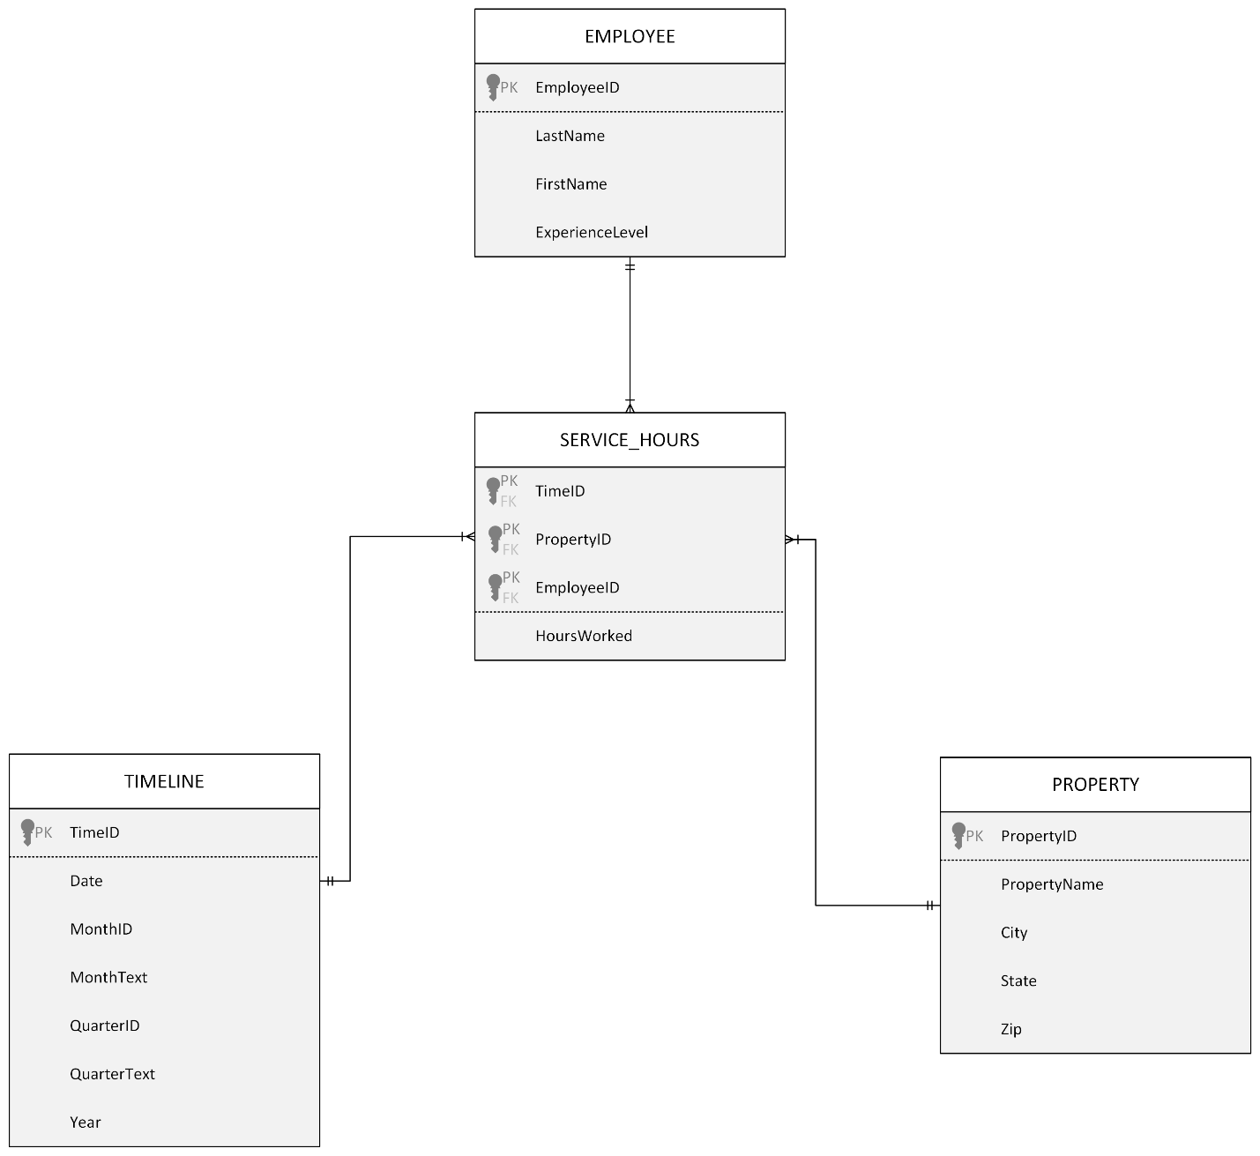

CREATE TABLE TIMELINE (
TimeID INT PRIMARY KEY,
Date DATE NOT NULL,
MonthID INT NOT NULL,
MonthText CHAR(15),
QuarterID INT,
QuarterText CHAR(10),
Year CHAR(10)
);
CREATE TABLE PROPERTY (
PropertyID INT PRIMARY KEY,
PropertyName CHAR(50),
City CHAR(35),
State CHAR(2),
Zip CHAR(10)
);

CREATE TABLE EMPLOYEE (
EmployeeID INT PRIMARY KEY,
LastName CHAR(25),
FirstName CHAR(25),
ExperienceLevel CHAR(15)
);

CREATE TABLE SERVICE_HOURS (
TimeID INT,
PropertyID INT,
EmployeeID INT,
HoursWorked NUMERIC(4,2),
PRIMARY KEY (TimeID, PropertyID, EmployeeID)
FOREIGN KEY (TimeID) REFERENCES TIMELINE(TimeID),
FOREIGN KEY (PropertyID) REFERENCES PROPERTY(PropertyID),
FOREIGN KEY (EmployeeID) REFERENCES EMPLOYEE(EmployeeID)
);

- Create the GG-DW database in a DBMS product. Not required, as the GG-DW Database-Ch-07.accdb Access database file has been provided for you in D2L.
- Not required
- Not required.
- Not required
- Write an SQL query that uses the hours worked per day as the measure. See specific instructions below:
In the GG-DW Database-Ch-07.accdb, create an SQL query that displays the EmployeeID, ExperienceLevel, PropertyID, City, State, Zip, and a total of hours worked with a heading of TotalHoursWorked. Group by EmployeeID, ExperienceLevel, PropertyID, City, State, Zip. Sort by EmployeeID, ExperienceLevel, State, City, Zip. Your query output should match the output below.
SELECT
EMPLOYEE.EmployeeID,
EMPLOYEE.ExperienceLevel,
PROPERTY.PropertyID,
PROPERTY.City,
PROPERTY.State,
PROPERTY.Zip,
SUM(SERVICE_HOURS.HoursWorked) AS TotalHoursWorked
FROM
(SERVICE_HOURS
INNER JOIN EMPLOYEE ON SERVICE_HOURS.EmployeeID = EMPLOYEE.EmployeeID)
INNER JOIN PROPERTY ON SERVICE_HOURS.PropertyID = PROPERTY.PropertyID
GROUP BY
EMPLOYEE.EmployeeID,
EMPLOYEE.ExperienceLevel,
PROPERTY.PropertyID,
PROPERTY.City,
PROPERTY.State,
PROPERTY.Zip
ORDER BY
EMPLOYEE.EmployeeID,
EMPLOYEE.ExperienceLevel,
PROPERTY.State,
PROPERTY.City,
PROPERTY.Zip;

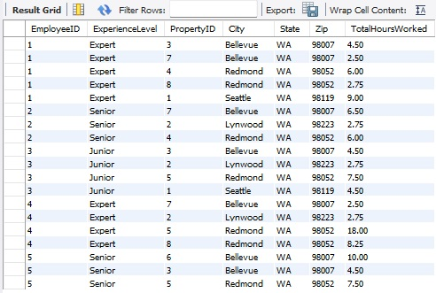

- Write the SQL view equivalent of the SQL query you wrote to answer part G.
Views are covered in Extension B.
CREATE VIEW TotalHoursWorked AS
SELECT
EMPLOYEE.EmployeeID,
EMPLOYEE.ExperienceLevel,
PROPERTY.PropertyID,
PROPERTY.City,
PROPERTY.State,
PROPERTY.Zip,
SUM(SERVICE_HOURS.HoursWorked) AS TotalHoursWorked
FROM
(SERVICE_HOURS
INNER JOIN EMPLOYEE ON SERVICE_HOURS.EmployeeID = EMPLOYEE.EmployeeID)
INNER JOIN PROPERTY ON SERVICE_HOURS.PropertyID = PROPERTY.PropertyID
GROUP BY
EMPLOYEE.EmployeeID,
EMPLOYEE.ExperienceLevel,
PROPERTY.PropertyID,
PROPERTY.City,
PROPERTY.State,
PROPERTY.Zip
ORDER BY
EMPLOYEE.EmployeeID,
EMPLOYEE.ExperienceLevel,
PROPERTY.State,
PROPERTY.City,
PROPERTY.Zip;
- Not required.
- Create an Excel for Microsoft 365 workbook named GG-DW-BI-Exercises.xlsx.
This is self-explanatory.
- Using the results of your SQL query from part G, copy the results of the query into a worksheet in the GG-DW-BI.xlsx workbook and then format this range as a worksheet table. Create a pivot table similar to what is shown below. Save the final Excel spreadsheet for submission into D2L
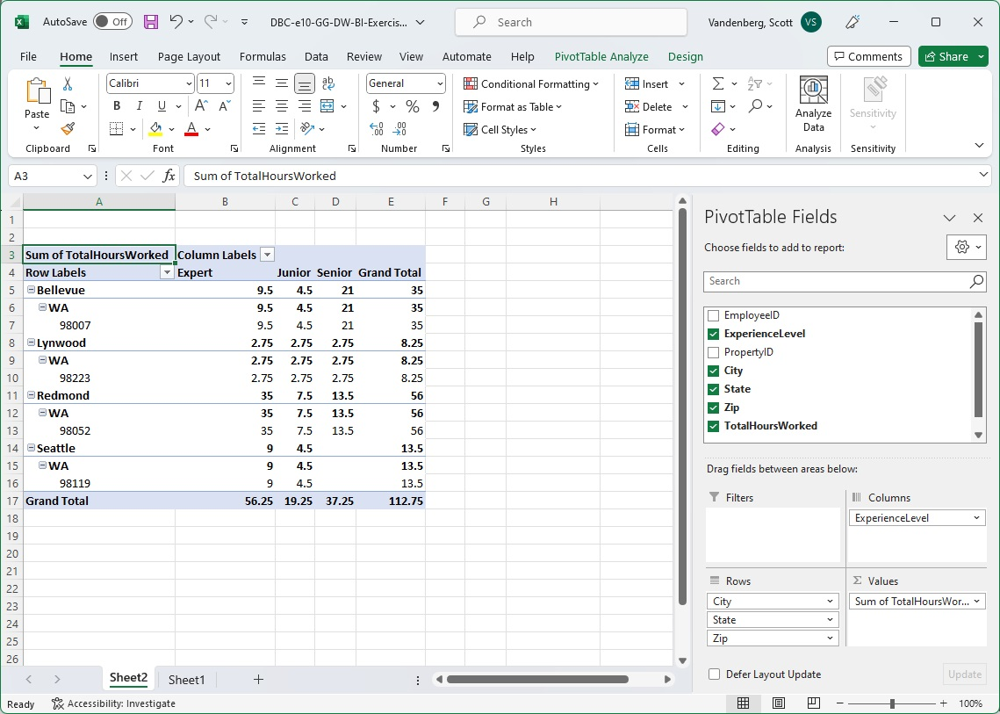
- Using the GG-DW Database-Ch-07 file that you worked with in Item A, construct a table similar to that below, based on the data in the PROPERTY_SERVICE and GG_SERVICE tables. Note that in a database this small, you can do this by hand. In a larger database, SQL can be used to create the table.

 | Mow Lawn | Plant Annuals | Weed Garden | Trim Hedge | Prune Small Tree | Trim Medium Tree | Trim Large Tree
8 Properties | 4 | 2 | 3 | 2 | 1 | 0 | 1
Mow Lawn | 0 | 0 | 3 | 0 | 0 | 0 | 0
Plant Annuals | 0 | 0 | 0 | 0 | 0 | 0 | 0
Weed Garden | 3 | 0 | 0 | 0 | 0 | 0 | 0
Trim Hedge | 0 | 0 | 0 | 0 | 1 | 0 | 1
Prune Small Tree | 0 | 0 | 0 | 1 | 0 | 0 | 0
Trim Medium Tree | 0 | 0 | 0 | 0 | 0 | 0 | 0
Trim Large Tree | 0 | 0 | 0 | 1 | 0 | 0 | 0
No other service | 1 | 2 | 0 | 0 | 0 | 0 | 0

- Based on your answer to the previous question, identify a pair of services that occurs together frequently. For this pair (A, B) compute the support, the confidence of A given B, the confidence of B given A, and the lift.
Support (How often both services appear together, out of all properties) = 5/30
Confidence (Mow Lawn -> Plant Annuals) = 5/17
Confidence (Plant Annuals -> Mow Lawn) = 5/9
Lift = (5/17) / (9/30) = 150/153

- Suppose that Garden Glory wants to be able to predict which properties are likely to be “repeat customers”. As part of this effort, they will add a Multiple Visits column to the OWNED_PROPERTY table (this will be a “yes/no” column). Describe, in general terms, how a decision tree, in conjunction with this new data, might help Garden Glory to predict which properties will be visited more than once.
If Garden Glory adds a “Multiple Visits” yes/no column, they could use a decision tree to help predict which properties will most likely become repeat customers. A decision tree looks at existing data and finds patterns that lead to either a “yes” or “no” for multiple visits. For example, the tree might discover properties in certain neighborhoods, or ones with specific services like “Mow Lawn” or “Weed Garden”, are more likely to be visited again. The decision tree splits the data based on different conditions, like location, number of services, or property type. As you go down the tree, each split gets more specific until it decides whether a property is likely to schedule future visits. It helps the company see what factors matter most regarding customer retention. Overall, this predictive model would allow Garden Glory to focus on high-potential properties and plan marketing or follow-up strategies more effectively.
Submit the following files into D2L for grading:
- This Microsoft Word assignment file with answers to the items
- Final DBC-e10-GG-Ch-7-Start.accdb database
- Final GG-DW Database-Ch-07.accdb database
- Final DBC-e10-GG-DW-BI-Exercises.xlsx spreadsheet file.

